Memo No.: 10/NOTICE/PL/2022 Date: 20/02/2022

NOTICE

This is to notify all that college will remain closed from 2.00 pm on 21/02/22, for paying homage and respect to departed SHRI SADHAN PANDE, Hon'ble Minister, Government of West Bengal (vide No. 686–F(P2) Dated: 20.02.2022).
All Semester 1 Internal Exams scheduled for second half of 21/02/2022, Monday is being postponed to 22/02/22, Tuesday. Other exams remain unchanged.
Students are directed to follow the revised time-table (enclosed)

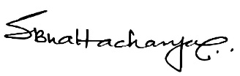
DR. SRABANTI BHATTACHARYA
Principal

